Chapter 13: The Expansion of American Industry
Section 1 (p. 456-465)
Vocabulary
Patent-

Productivity-

Transcontinental Railroad-

Bessemer Process-

Mass Production-

Questions
- Why did the nation’s industrial production rise in the late 1800s?

- Why did the oil business change after Drake found oil in Pennsylvania?

- How did inventions such as the light bulb and the telegraph change daily life in the late 1800s?

- What effect did electricity have on industrial production?

- What effect did electricity have on production costs?

- Transcontinental Railroad
  - What was the transcontinental railroad?

  - Why were private invested not interested in building railroads beyond the line of settlement?

  - Who stepped in to build the transcontinental railroad?

  - Why was Congress interested in building the transcontinental railroad?

  - What two major immigrant groups built the transcontinental railroad?

  - Why did the railroads develop the system of time zones?

  - What effect did rail transport have on shipping costs?

  - What six advantages did rail transport have over canals, turnpikes, and steam ships?

    - ____________________________________________________________________________________________________________________________________________________________

    - ____________________________________________________________________________________________________________________________________________________________

    - ___________________________________________________________________________________________________________________________________________________________

    - ____________________________________________________________________________________________________________________________________________________________

    - ____________________________________________________________________________________________________________________________________________________________

    - ____________________________________________________________________________________________________________________________________________________________

- What innovations did the Bessemer process encourage?

In Your Own Words
- Why do you think reducing shipping costs was so important?

- In what way might the Civil War have encouraged Congressmen to want to build the Transcontinental Railroad?

- Why do you think Americans were not interested in living in the American West before the Transcontinental Railroad?

- What effect do you think that the new rail lines had on Indians living the American West?

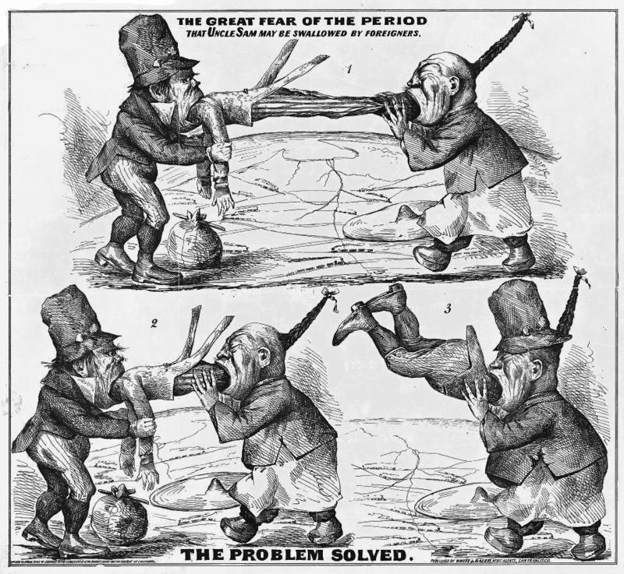

Note: The two figures that are eating Uncle Sam are Irish Immigrants (left) and Chinese immigrants (right.)

- What does the cartoon seem to be saying that the Irish and Chinese immigrants are doing to America?

- What does the cartoon seem to be saying will happen after the Irish and Chinese finish eating Uncle Sam?

- What immigrant group does the author seem to fear the most?

- Do you think that our current debate over immigration bears any resemblance to this cartoon? Why/why not?

