Industrial Age and Inequality
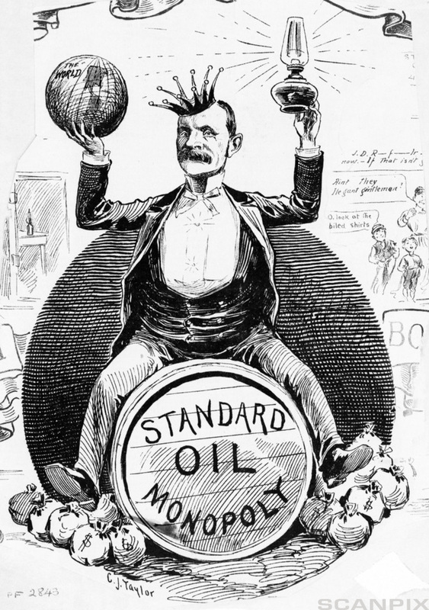
Questions
- What does businessman (Rockefeller) have on his head? _____________________________________________
___________________________________________________________________________________
- What two things is Rockefeller holding in his hands?
  - ________________________________________________
  - ________________________________________________

- What do you think the cartoonist is trying to imply about Rockefeller? __________________________________
___________________________________________________________________________________________
___________________________________________________________________________________________
___________________________________________________________________________________________
___________________________________________________________________________________________
___________________________________________________________________________________________

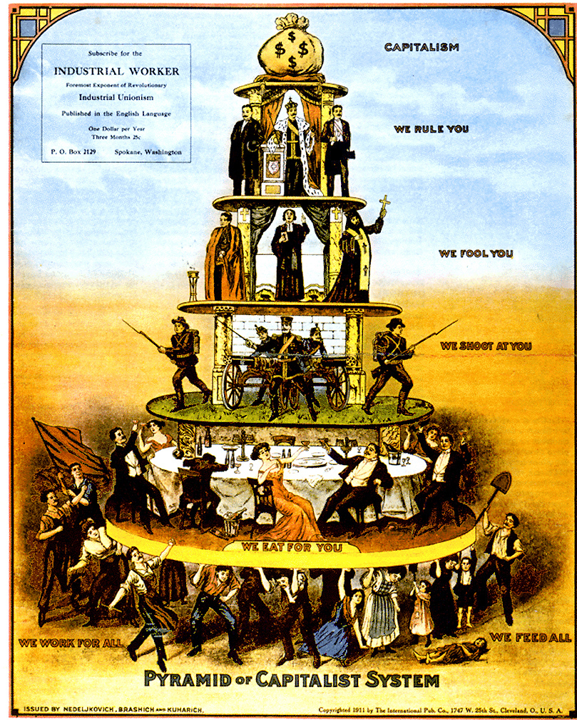
Note: This cartoon was produced by radical labor unions to protest 19th century capitalism.
- What do the workers at the base of the pyramid do? ________________________________________________
- What do the wealthy on the second layer of the pyramid do? _________________________________________
- What do the soldiers on the third layer of the pyramid do? ___________________________________________
- What do the priests on the fourth layer of the pyramid do? ___________________________________________
- What do the kings and leaders do on the fifth layer of the pyramid? ____________________________________
- What is at the peak of the pyramid? ______________________________________________________________
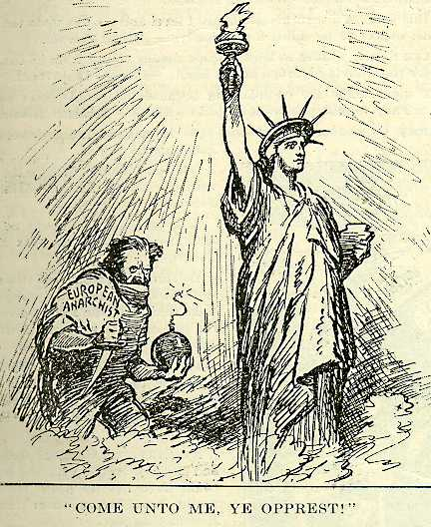
Note: “European Anarchist” was a general term used to describe radical politics of the time. Often it included Marxists, classical anarchists, radical unionists, and other traditions.
- Who is the person on the right? _________________________________________________________________
- What is Lady Liberty offering the people of the world? _______________________________________________
___________________________________________________________________________________________
- Who is the person on the left? __________________________________________________________________
- What does the person on the left seem to be about to do? ____________________________________________
___________________________________________________________________________________________
- What do you think the author is suggesting about those who have radical politics? ________________________
___________________________________________________________________________________________
___________________________________________________________________________________________
___________________________________________________________________________________________
___________________________________________________________________________________________
___________________________________________________________________________________________

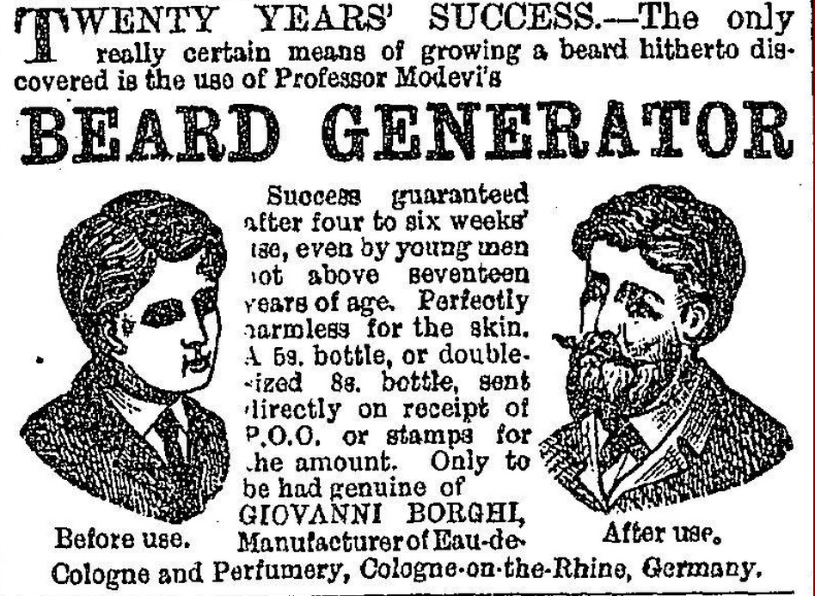
Questions
- Is this invention fair to those of us with magnificent beards naturally? _________________________
___________________________________________________________________________________
___________________________________________________________________________________
___________________________________________________________________________________
___________________________________________________________________________________
- Do you think this beard generator is a helpful invention to those cursed with bald chins? ___________
___________________________________________________________________________________
___________________________________________________________________________________
___________________________________________________________________________________
___________________________________________________________________________________

