Prompt: Is fascism defined by its ideals or by those ideals that it is opposed to?
Using the 14 points that Umberto Eco assigns to fascism, make a decision: Is fascism defined by the beliefs that it espouses or by those beliefs it is opposed to? Go through each point and decide how each point supports your assertion.
You only need to choose 10 of the 14 points to make your argument.

Point | Defined by Fascist Ideals | Defined by those ideals to which is opposed.
First Point

The first feature of Ur-Fascism is the cult of tradition. Traditionalism is of course much older than fascism. Not only was it typical of counter-revolutionary Catholic thought after the French revolution, but it was born in the late Hellenistic era, as a reaction to classical Greek rationalism. In the Mediterranean basin, people of different religions (most of them indulgently accepted by the Roman Pantheon) started dreaming of a revelation received at the dawn of human history. This revelation, according to the traditionalist mystique, had remained for a long time concealed under the veil of forgotten languages—in Egyptian hieroglyphs, in the Celtic runes, in the scrolls of the little known religions of Asia.
As a consequence, there can be no advancement of learning. Truth has been already spelled out once and for all, and we can only keep interpreting its obscure message.

Second Point

Traditionalism implies the rejection of modernism. Both Fascists and Nazis worshiped technology, while traditionalist thinkers usually reject it as a negation of traditional spiritual values. However, even though Nazism was proud of its industrial achievements, its praise of modernism was only the surface of an ideology based upon Blood and Earth (Blut und Boden). The rejection of the modern world was disguised as a rebuttal of the capitalistic way of life, but it mainly concerned the rejection of the Spirit of 1789 (and of 1776, of course). The Enlightenment, the Age of Reason, is seen as the beginning of modern depravity. In this sense Ur-Fascism can be defined as irrationalism.

Third Point

Irrationalism also depends on the cult of action for action’s sake. Action being beautiful in itself, it must be taken before, or without, any previous reflection. Thinking is a form of emasculation. Therefore culture is suspect insofar as it is identified with critical attitudes. Distrust of the intellectual world has always been a symptom of Ur-Fascism, from Goering’s alleged statement (“When I hear talk of culture I reach for my gun”) to the frequent use of such expressions as “degenerate intellectuals,” “eggheads,” “effete snobs,” “universities are a nest of reds.” The official Fascist intellectuals were mainly engaged in attacking modern culture and the liberal intelligentsia for having betrayed traditional values.

Fourth Point

No syncretistic faith can withstand analytical criticism. The critical spirit makes distinctions, and to distinguish is a sign of modernism. In modern culture the scientific community praises disagreement as a way to improve knowledge. For Ur-Fascism, disagreement is treason.

Fifth Point

Besides, disagreement is a sign of diversity. Ur-Fascism grows up and seeks for consensus by exploiting and exacerbating the natural fear of difference. The first appeal of a fascist or prematurely fascist movement is an appeal against the intruders. Thus Ur-Fascism is racist by definition.

Sixth Point

Ur-Fascism derives from individual or social frustration. That is why one of the most typical features of the historical fascism was the appeal to a frustrated middle class, a class suffering from an economic crisis or feelings of political humiliation, and frightened by the pressure of lower social groups. In our time, when the old “proletarians” are becoming petty bourgeois (and the lumpen are largely excluded from the political scene), the fascism of tomorrow will find its audience in this new majority.

Seventh Point

To people who feel deprived of a clear social identity, Ur-Fascism says that their only privilege is the most common one, to be born in the same country. This is the origin of nationalism. Besides, the only ones who can provide an identity to the nation are its enemies. Thus at the root of the Ur-Fascist psychology there is the obsession with a plot, possibly an international one. The followers must feel besieged. The easiest way to solve the plot is the appeal to xenophobia. But the plot must also come from the inside: Jews are usually the best target because they have the advantage of being at the same time inside and outside. In the US, a prominent instance of the plot obsession is to be found in Pat Robertson’s The New World Order, but, as we have recently seen, there are many others.
Eighth Point

The followers must feel humiliated by the ostentatious wealth and force of their enemies. When I was a boy I was taught to think of Englishmen as the five-meal people. They ate more frequently than the poor but sober Italians. Jews are rich and help each other through a secret web of mutual assistance. However, the followers must be convinced that they can overwhelm the enemies. Thus, by a continuous shifting of rhetorical focus, the enemies are at the same time too strong and too weak. Fascist governments are condemned to lose wars because they are constitutionally incapable of objectively evaluating the force of the enemy.
Ninth Point

For Ur-Fascism there is no struggle for life but, rather, life is lived for struggle. Thus pacifism is trafficking with the enemy. It is bad because life is permanent warfare. This, however, brings about an Armageddon complex. Since enemies have to be defeated, there must be a final battle, after which the movement will have control of the world. But such a “final solution” implies a further era of peace, a Golden Age, which contradicts the principle of permanent war. No fascist leader has ever succeeded in solving this predicament.

Tenth Point

Elitism is a typical aspect of any reactionary ideology, insofar as it is fundamentally aristocratic, and aristocratic and militaristic elitism cruelly implies contempt for the weak. Ur-Fascism can only advocate a popular elitism. Every citizen belongs to the best people of the world, the members of the party are the best among the citizens, every citizen can (or ought to) become a member of the party. But there cannot be patricians without plebeians. In fact, the Leader, knowing that his power was not delegated to him democratically but was conquered by force, also knows that his force is based upon the weakness of the masses; they are so weak as to need and deserve a ruler. Since the group is hierarchically organized (according to a military model), every subordinate leader despises his own underlings, and each of them despises his inferiors. This reinforces the sense of mass elitism.
Eleventh Point

In such a perspective everybody is educated to become a hero. In every mythology the hero is an exceptional being, but in Ur-Fascist ideology, heroism is the norm. This cult of heroism is strictly linked with the cult of death. It is not by chance that a motto of the Falangists was Viva la Muerte (in English it should be translated as “Long Live Death!”). In non-fascist societies, the lay public is told that death is unpleasant but must be faced with dignity; believers are told that it is the painful way to reach a supernatural happiness. By contrast, the Ur-Fascist hero craves heroic death, advertised as the best reward for a heroic life. The Ur-Fascist hero is impatient to die. In his impatience, he more frequently sends other people to death.

Twelfth Point

Since both permanent war and heroism are difficult games to play, the Ur-Fascist transfers his will to power to sexual matters. This is the origin of machismo (which implies both disdain for women and intolerance and condemnation of nonstandard sexual habits, from chastity to homosexuality). Since even sex is a difficult game to play, the Ur-Fascist hero tends to play with weapons—doing so becomes an ersatz phallic exercise.

Thirteenth Point

Ur-Fascism is based upon a selective populism, a qualitative populism, one might say. In a democracy, the citizens have individual rights, but the citizens in their entirety have a political impact only from a quantitative point of view—one follows the decisions of the majority. For Ur-Fascism, however, individuals as individuals have no rights, and the People is conceived as a quality, a monolithic entity expressing the Common Will. Since no large quantity of human beings can have a common will, the Leader pretends to be their interpreter. Having lost their power of delegation, citizens do not act; they are only called on to play the role of the People. Thus the People is only a theatrical fiction. To have a good instance of qualitative populism we no longer need the Piazza Venezia in Rome or the Nuremberg Stadium. There is in our future a TV or Internet populism, in which the emotional response of a selected group of citizens can be presented and accepted as the Voice of the People.
Because of its qualitative populism Ur-Fascism must be against “rotten” parliamentary governments. One of the first sentences uttered by Mussolini in the Italian parliament was “I could have transformed this deaf and gloomy place into a bivouac for my maniples”—“maniples” being a subdivision of the traditional Roman legion. As a matter of fact, he immediately found better housing for his maniples, but a little later he liquidated the parliament. Wherever a politician casts doubt on the legitimacy of a parliament because it no longer represents the Voice of the People, we can smell Ur-Fascism.
Fourteenth Point

Ur-Fascism speaks Newspeak. Newspeak was invented by Orwell, in 1984, as the official language of Ingsoc, English Socialism. But elements of Ur-Fascism are common to different forms of dictatorship. All the Nazi or Fascist schoolbooks made use of an impoverished vocabulary, and an elementary syntax, in order to limit the instruments for complex and critical reasoning. But we must be ready to identify other kinds of Newspeak, even if they take the apparently innocent form of a popular talk show.

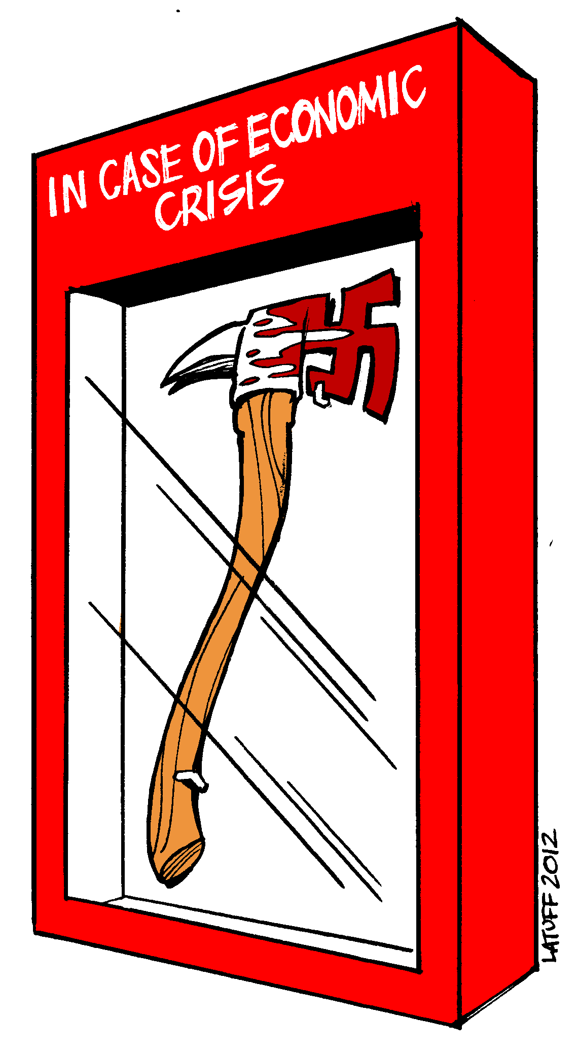
Consider the political cartoon. What do you think the author is trying to suggest about the threat of fascism? Do you agree? Why/why not?

