Japan in the Interwar Years
The Hermit Kingdom
Beginning in the Japan 1600s, Japan became known as the ‘Hermit Kingdom,’ and closed itself off from the rest of the world. Its leaders feared foreign ‘contamination’ of its culture, including Christianity and other European ideals, and so forbade nearly all foreigners from entering the country.
However, between the 1600s and 1850s, enormous political, economic, and technological changes occurred worldwide, all of which Japan missed out on. In the 1600s Japan had produced some of the finest firearms on the planet, but by the 1850s, they were hopelessly out-of-date. In nearly every way Japan had fallen technologically far behind its neighbors.
- Why was Japan known as “the Hermit Kingdom?”

- What effect did Japan policy of isolation have on its technology?

Meiji Restoration
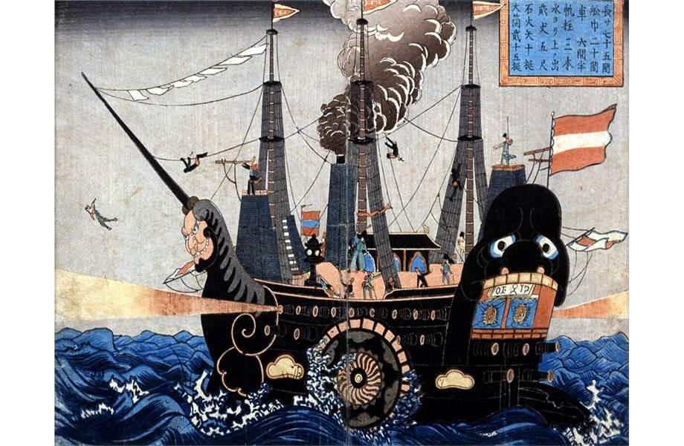
However, Japan did produce some of the highest quality silk in the world, which much of the rest of the world desired. In 1854, the United States sent a naval fleet to Japan to negotiate opening the nation to outside trade. The American fleet, powered by steam and bristling with modern cannons, terrified the Japanese. Japan’s leaders agreed to open their borders to trade rather than face American might.
- Why did the Americans send a fleet to Japan in 1854?

- The cartoon above is a Japanese cartoon which depicts one of the ships of Perry’s fleet. Describe the ship as portrayed. Why do you think the Japanese would draw it in such a fashion?

Japan’s leaders, shocked by how far they had fallen behind the outside world, undertook a crash development project, meant to turn Japan into a modern, industrial power. This period was known as the Meiji Restoration. The Japanese imported European and American technicians to train them in modern industrial techniques, including steel production, the development of steam power, modern agriculture, and other industries. Retired military officers from Britain, Germany, and the United States were also hired to help reorganize Japan’s antiquated military forces.
Soon, Japan had become a European-style industrial power. In 1905, war broke out between Japan and Russia, with Japan crushing the Russians in a series of battles. Europe was shocked that an Asian power had managed to beat one of the Great Powers of Europe in a modern war and Japan had proved its power.
- What was the goal of the Meiji Restoration? Was it a success?

- Where did Japan find technicians to help them with their projects?

- Why would Japan defeating Russia be a symbol of Japanese power?

Japan in World War I and the Russian Revolution
Japan allied with Britain and France during World War I and used the war as an opportunity to seize Germany’s colonies in Asia. The geographic distance (coupled with the British blockade of Germany) meant that the Germans could not properly defend their colonies and Japan was easily able to overcome the local defenses.
In 1917, with the outbreak of the Russian Revolution, the Japanese saw an opportunity to expand its influence in Asia. The chaos in Russia meant that the Japanese did not have to worry about potential Russian interference and began to strengthen its hold on China and Mongolia.
The Japanese joined other Western Powers, notably the United States and Britain, in invading the Soviet Union with the goal of defeating the Communist Revolution taking place there. 60,000 Japanese soldiers crossed China and invaded Siberia.
The Japanese government was very hostile to communism and feared that if Lenin’s forces won in Russia, communism would spread throughout the world, including to Japan. In Japan itself, laws were passed which outlawed Communist literature and Communist political parties.
Despite years of fighting, the Japanese were eventually driven out of Siberia by Soviet forces in 1922. While the invasion of Siberia was a failure, the Japanese were able to expand its power over China.
- How did Japan use World War I to strengthen its position in Asia?

- How did Japan use the Russian Revolution to strengthen its position in Asia?

- How did the Japanese government use its invasion of the Soviet Union to strengthen its position in Japan itself?

- Overall, how did geography benefit Japan during WWI and the Russian Revolution?

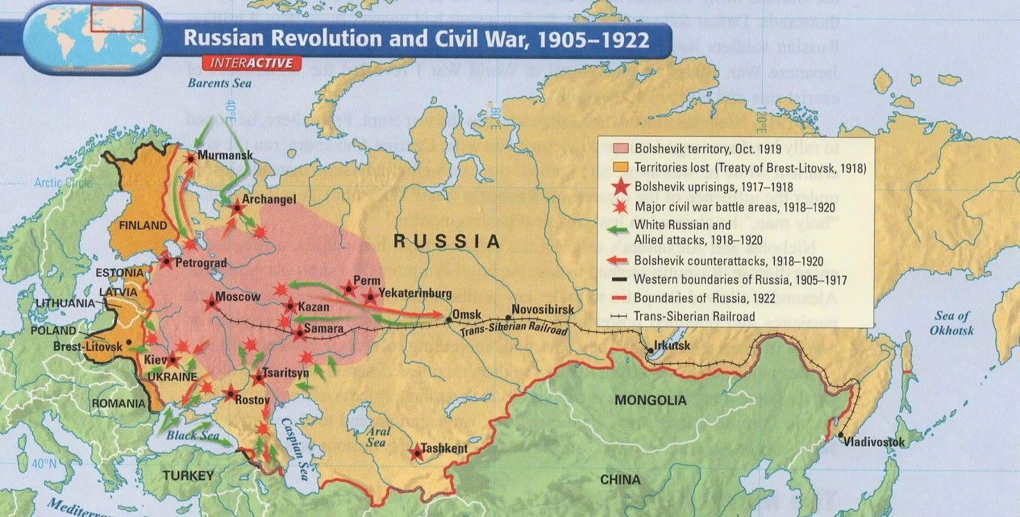
- It took the Red Army nearly 4 years to drive the Japanese out of Siberia. Consider the map above: Why do you think it took the Reds so long to defeat the Japanese?

The 1920s
The 1920s were a period of prosperity for Japan. Reforms at home allowed for an expansion of democracy, while economic growth created an increasingly stable middle-class for educated Japanese. After withdrawing from the Soviet Union, Japan was able to decrease the size of its armed forces and focus more on economic growth.
However, the 1920s also witnessed increased American activities in Asia and the Pacific. The destruction wrought in Europe by World War I meant that many American businesses sought opportunities elsewhere. While a fair amount of trade was conducted between the United States and Japan, American interests began to turn towards China.
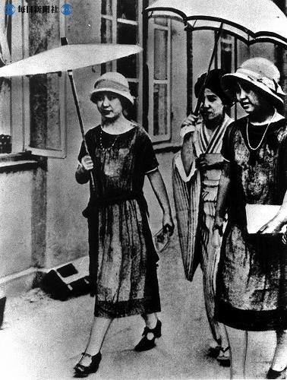
- Why might prosperity encourage democratic expansion?

- Why might American businesses in China be a threat towards Japan?

- Consider the image to the left. It is a photograph of three Japanese women in the 1920s. How does this picture explain the effectiveness of the Meiji Restoration?

- How might the picture indicate an unintended consequence of the Meiji Restoration?

China, with enormous resources and a large population, represented an important potential market. Tensions between the United States and Japan increased as they each struggled for economic and political power in China. By the mid-1920s, Japan and the United States had come to a series of mutually-supportive agreements regarding China and the future seemed quite bright between the two nations.

- Why did China appeal to the United States as well as the Japanese?

The 1930s and the Great Depression
Japan initially entered the Great Depression in a surprisingly stable condition. While the Depression caused an economic downturn, Japan’s Finance Minister, Yakahashi Korekiyo, moved quickly to counter any potential problems. He introduced a fiscal stimulus which helped to keep unemployment relatively low. Further, Yakahashi also devalued the Japanese currency, which made it worth less than it was before the crisis. This made its goods cheaper and soon Japanese textiles began to displace British textiles on the world market.
- How was Yakahashi able to keep Japan’s economy growing despite the worldwide Depression?

Yakahashi, focused on restoring Japan’s fiscal situation, sought to reduce military spending with the goal of increasing industrial production. The military was viciously opposed to any potential cuts and a dissident group of military officers assassinated him in February of 1936. This had a crippling effect on democracy and civil government in Japan during the remainder of the decade. With the assassination of Yakahashi, the military began to slowly take over life in Japan, so that by 1940, there was no serious political force in Japan outside of the armed forces.

- Why was Yakahashi assassinated?

- With the collapse of Japanese democracy, who took power in Japan?

The Second Sino-Japanese War
In 1937, the Japanese military, emboldened by its growing power, returned to preying on China. Despite forcing a series of economic and political demands on China, war did not start until a fairly minor event in July of 1937 at the Marco Polo Bridge. It is unclearly exactly what started this incident, but Chinese and Japanese forces engaged in a confused and sporadic skirmish that ultimately led to full-scale war. The fighting would be marked with horrific atrocities (committed primarily by the Japanese against Chinese civilians), including the horrific Rape of Nanking.
The Second Sino-Japanese War would not end until 1945.
Compare and Contrast Japan’s democratic government from the 1920’s to Japan’s new military government in regards to how it treated China.
Compare | Contrast
Western Imperialism and the New Japanese Empire
Europe and America had long held colonies in East Asia, during the Industrial Revolution. By the 1930s, France, Britain, the Netherlands, and the United States had emerged as the predominant colonial powers in the region, save for Japan itself.
These colonies were enormously wealthy and the Japanese military government was very interested in acquiring them. However, there was no way that Japan could defeat the combined forces of these European powers, so plans were prepared so that if another war in Europe were to break out, Japan would take advantage of the chaos to seize these colonies.
- What nations had colonized parts of Asia?

- Why was Japan fearful of trying to seize those colonies for itself?

That only left the United States to contend with. The Japanese military did not want war with the United States, and was content to allow the Americans to maintain their own colonies in Asia rather than risk war. However, in the event that the Japanese military took the Dutch, British, and French colonies, how would the United States respond? The Japanese military had no idea how the Americans would react: would they come to the European Powers aid or ignore it altogether?
Further, the Japanese military knew that it could not with a long, drawn-out war with the United States, which had vastly more resources at its disposal. However, a plan was agreed to:
- In the event of a war in Europe, which would distract Europe’s colonial powers, the Japanese military would seize control of their colonies.
- American colonies in Asia would be seized and a vicious strike against the U.S. Pacific Fleet at Pearl Harbor would also be launched. The goal was that if the U.S. fleet was destroyed, the Americans might be willing to negotiate a peace treaty, given that amount of time/wealth it would take to rebuild a navy from scratch.
Some Japanese military commanders were opposed to antagonizing the United States, given the unpredictability of the outcome. Pro-war leaders suggested that if they did not take the American colonies or quickly defeat the American forces in Asia, American forces would be on alert and able to crush the Japanese in a long-term struggle. In the end, pro-war leaders won out.
- What did the Japanese hope would distract European powers from raids on their colonies?

- Why was the Japanese government wary of war with the United States?

- Why did the Japanese military feel that it had to attack American forces in the Pacific?

Big Picture: How was Japan’s decision to seclude itself from the rest of the world for two centuries a mistake?

Big Picture: How did World War I undermine Europe’s control of the world?

Big Picture: How was America’s decision to send its fleet to Japan in 1854 a mistake?

Big Picture: How was the American/Europe decision to seize colonies in Asia a mistake?

Big Picture: Why do you think that Japan would later be willing to ally itself with Nazi Germany, given its war plans?

