The Soviet Union in the Interwar Years
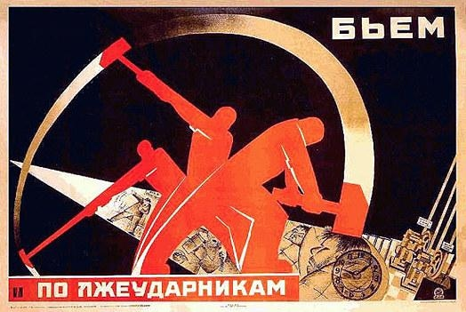
In 1924, V. I. Lenin died from health problems brought about by a failed assassination attempt in 1919. His death, coupled with the collapse of other socialist revolutions in Europe and the United States, left the Soviet Union in a precarious place. It was encircled by hostile enemies, destroyed by World War I and the Russian Civil War, and had no foreign friends to speak of.
The Soviet Union had long had an official policy of “International Revolution,” which hoped to use the Soviet Union as a base of support to spread socialist revolution across the world. Soviet thinkers believed that unless the revolution was spread, the Soviet Union would be cut off and eventually overwhelmed by capitalist power.
Realizing that they could not rely on the outside world, the Soviet Union began its policy of “Socialism in One Country.” Spearheaded by Josef Stalin, a longtime Bolshevik leader, the Communist government determined that they had to undertake a project of economic modernization and expansion on their own.
This began a crash program of industrialization, which aimed to transform the backward Tsarist Empire they had inherited into a modern, industrial power. According to Stalin, head of the Soviet government,
"We are fifty or a hundred years behind the advanced countries. We must make up this gap in ten years. Either we do it or they will crush us."
- How does the goal of the Soviet government change in the interwar years?

- What did Stalin believe had to be done to protect the Soviet Union?

Social Conditions
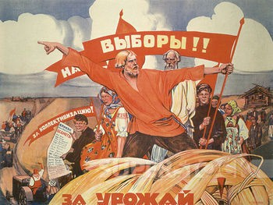
The Soviets immediately began to transform the conservative, feudal society of Russia into a modern society. Under the Lenin, the Soviet Union guaranteed women the right to vote, liberalized divorce laws, ended child labor, decriminalized homosexuality, ended violence against Jews and other minorities in the Soviet Union, guaranteed free education to all children, implemented adult literacy programs, and a host of other reforms.
These reforms upended centuries of social control by feudal nobility and effectively emancipated women in the Soviet Union. Women were able to enter government, employment, own their own property, and participate in society in ways never before possible.
The Soviet focus on education was particularly strong, especially given the conditions on the ground: most people were illiterate farmers. These adult literacy classes were particularly popular as many adults wanted to learn how to read: even after working a full day, millions of adults were go to the local schools to learn how to read. The generation that grew up after the Russian Revolution was the first universally literate generation as a result of the education policies.
Pogroms (organized violent attacks) against Jewish and other minority communities in the Soviet Union were ended. The Soviet government put a new emphasis on protecting the rights of ethnic minorities. Under the Tsars, all education in the empire had to be conducted in Russian; under the Soviets, local languages were being used in the schools.
For the first time, widespread immunization programs were carried out, leading to a longer life expectancy for the average Soviet citizen versus under the Tsars.
How did each group’s lives improve under the new Soviet Regime?
Women
Ethnic Minorities
Illiterate adults
Children
Homosexuals

Agricultural Program
In the Russian Empire, most Russians were farmers who worked for feudal lords or wealthy peasants known as Kulaks. When the Russian Revolution happened, the enormous farms of the nobility were broken up and the land turned over to the peasants who farmed it.
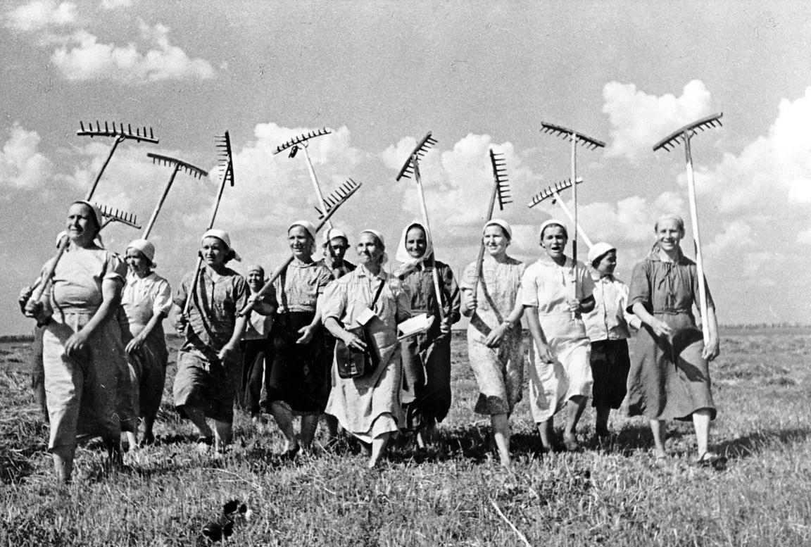
By the mid-1920s, a new agricultural program was implemented by the government. The goal of this program was Collectivization, or the establishment of large scale farms which were jointly held by peasants who worked them together. Many smaller farms and all of the Kulak’s land was seized and converted into Collective Farms.
This process was very chaotic and led to some dislocation. Further, farming conditions were not ideal in Russia: while This, coupled with a drought in 1932-1933, led to a terrible harvest which caused food insecurity for millions of Soviet citizens. Numbers are unclear, but a number of Soviet citizens died from hunger, or diseases brought about by malnutrition.
- What did the Soviet government do with the large feudal farms?

- Who were the Kulaks?

- What was the goal of the Collective Farms?

- What was the outcome of the Collective Farms?

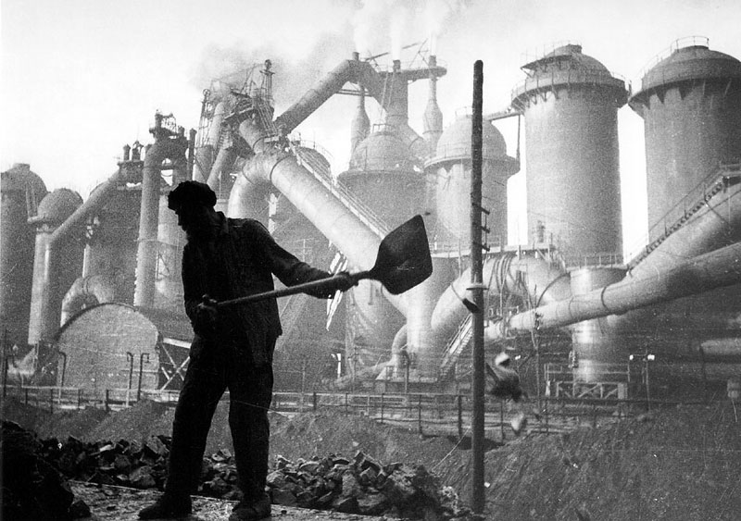
Economic Program
The Soviet Government undertook a Crash Industrialization Program to try and develop its own industrial base. The Tsars had left Russia tremendously backwards and the Soviet government felt that it needed to quickly try and “catch up” with its neighbors. The Soviet economy began to grow very rapidly as new factories were built across the country. Soon the Soviet Union became the world’s leading producer of oil, coal, iron ore, and cement.
Under the Tsars, Russia had no automobile industry; by 1931, Soviet car and truck production reached 200,000 per year. The Soviet aviation industry was built entirely from scratch to begin competing with its capitalist neighbors. Railroads, canals, and roads were modernized and built to ensure that the country could continue to expand.
While the capitalist world languished in the Great Depression, the Soviet economy had an effective 0% unemployment rate. This became attractive to many in the capitalist world, leading some engineers and other skilled workers to move to the Soviet Union to assist in its development.
- What condition did the Tsars leave Russian industries in?

- What was the goal of the Soviet Industrialization program?

- How effective was this Industrialization program?

- Why were some engineers/skilled workers willing to move to the Soviet Union during the 1930s?

International Appeal
Many were drawn to the Soviet Union for ideological reasons. Many African specialists, whose nations were colonized by European nations, moved to the Soviet Union. These specialists had been trained in important industrial and agricultural techniques that the struggling Soviet Union needed and so were afforded considerable respect in the Soviet Union. Plus, the Soviet Union’s official policies of anti-racism and its stated goal to see the end of imperialism worldwide was attractive to many people under colonial domination.
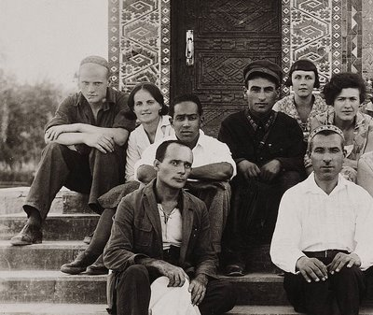
- What two Soviet policies did colonized people appreciate?

African-American poet Langston Hughes travelled to the Soviet Union and was impressed with what he saw there. He wrote glowingly of the Soviet experiment and believed that communism would one day end racism and hunger. So moved was Hughes, he wrote a poem about his experience,
Lenin
Lenin Walks around the world.
Frontiers cannot bar him.
Neither barracks not barricades impede.
Not does barbed wire scar him.

Lenin walks around the world.
Black, brown, and white receive him.
Language is no barrier.
The strangest tongues believe him.

Lenin walks around the world.
The sun sets like a scar.
Between the darkness and the dawn.
There rises a red star.
- Consider Hughes’ poem: what does Hughes seem to be implying about the future of communism?

The Costs
It is unclear how many people died during this period. This was partially due to international propaganda and efforts by the Soviet government to hide the situation from its enemies in the capitalist world. The rapid industrialization program meant that much of the Soviet Union’s limited resources were being put into industrialization, rather than human needs. With this rapid expansion, workers often worked long hours. Coupled with international isolation and a terrible drought in 1932-1933, working people suffered during this period.
- Why was the industrialization period so difficult for Soviet workers?

Outcome
Ultimately, the Soviet Union’s program was successful in terms of its economic goals. It transformed itself from a backwards, Tsarist agrarian nation into an industrial power. While it was still isolated and besieged on all sides, it had managed to build its own internal industries despite the situation.
- How successful was the Soviet industrialization program?

Soviet Industrialization Vocabulary

International Revolution-
__________________________________________________________________________________________________
__________________________________________________________________________________________________
__________________________________________________________________________________________________
__________________________________________________________________________________________________

Socialism In One Country-
__________________________________________________________________________________________________
__________________________________________________________________________________________________
__________________________________________________________________________________________________
__________________________________________________________________________________________________

Pogroms-
__________________________________________________________________________________________________
__________________________________________________________________________________________________
__________________________________________________________________________________________________
__________________________________________________________________________________________________

Kulaks-
__________________________________________________________________________________________________
__________________________________________________________________________________________________
__________________________________________________________________________________________________
__________________________________________________________________________________________________

Collectivization-
__________________________________________________________________________________________________
__________________________________________________________________________________________________
__________________________________________________________________________________________________
__________________________________________________________________________________________________

Crash Industrialization Program-
__________________________________________________________________________________________________
__________________________________________________________________________________________________
__________________________________________________________________________________________________
__________________________________________________________________________________________________

