Why Did It Happen There?
Question: Why did fascism to come to power in Germany, but fail in Britain?
Though fascism was developed in Italy, it became increasingly popular throughout Europe during the 1920s. By the 1930s, fascism would have come to power in Italy, Germany, Portugal, Spain, Poland, Greece, and Croatia. Other nations had powerful fascist movements that were unable to take power, including Britain, France, Sweden, Norway, Denmark and the United States.
You will be trying to determine why fascism succeeded in Germany, but failed to gain power in Britain. You will be looking at the political, economic, and social reasons for this disparity.

Oswald Mosley
Nationality:
Birth – Death:
Political Party:
Ideology:
Military Unit During WWI:
Quote:
Adolph Hitler
Nationality:
Birth-Death:
Political Party:
Ideology:
Military Unit During WWI:
Quote:

For each of the following, include at least two points in both ‘compare’ and two points in ‘contrast.’
Compare and contrast the economic situation in each nation in the 1920s.
Comparison- Germany and Britain | Contrast- Germany and Britain

How did the economic situation in Germany in the 1920s help fascism come to power? _________________________
__________________________________________________________________________________________________
__________________________________________________________________________________________________
Compare and Contrast each of the two political parties.
Comparison- The British Union of Fascists  and the Nazi Party |  | Contrast- The British Union of Fascists  and the Nazi Party
The Beerhall Putsch
Identify two important figures from the event.
Provide a brief description of the events.
What was the outcome of the event?
The Battle of Cable Street
Identify two important figures from the event.
Provide a brief description of the events.
What was the outcome of the event?
The Beerhall Putsch and the Battle of Cable Street
Compare |  |  | Contrast

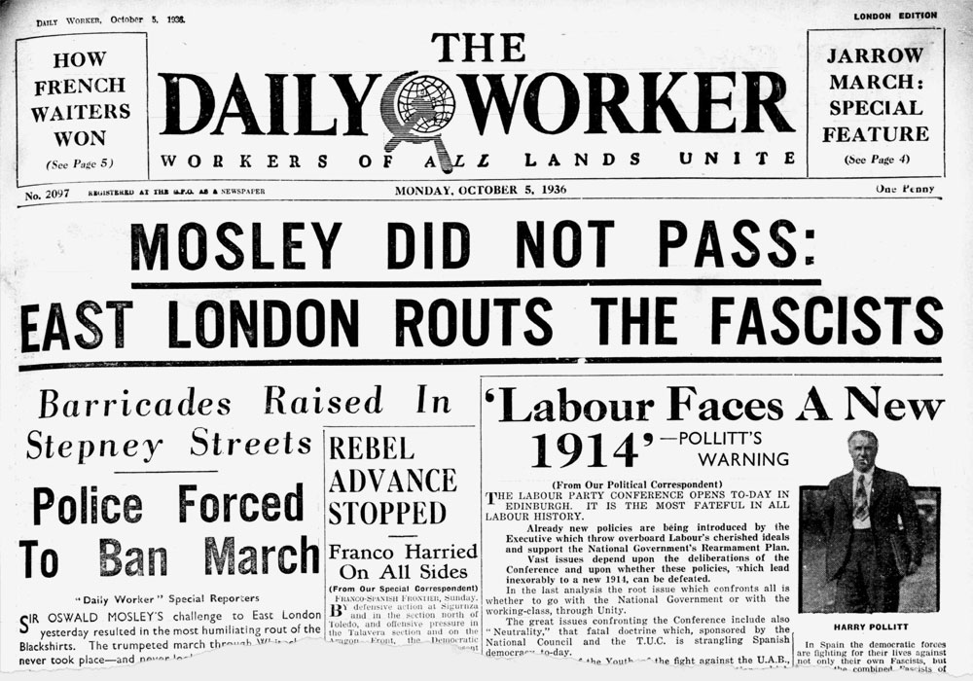
The Night of the Long Knives
Identify two important figures from the event.
Provide a brief description of the events.
What was the outcome of the event?

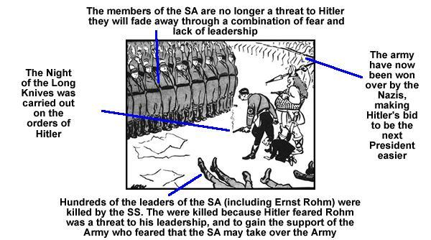

The Public Order Act (1936)
Identify two important figures from the event.
Provide a brief description of the events.
What was the outcome of the event?

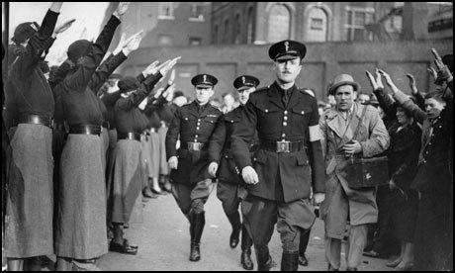

Compare and Contrast: The Night of the Long Knives and Public Order Act (1936)
Compare | Contrast

Why was Britain able to resist the rise of fascism while Germany was not?
Economic Reasons
Political Reasons
Social Reasons

